Hindi Vidya Prachar Samiti’s
RAMNIRANJAN JHUNJHUNWALA COLLEGE OF ARTS, SCIENCE AND COMMERCE
(EMPOWERED AUTONOMOUS)

Soft Computing


Name: Surajkumar Yadav
Roll no: 10302
Class: MSc. Data Science and Artificial Intelligence Part I


Ramniranjan Jhunjhunwala College
of Arts, Science and Commerce

Department of Data Science and Artificial Intelligence

CERTIFICATE

This is to certify Surajkumar Yadav of MSc. Data Science and Artificial Intelligence Roll No 10302 has successfully completed the practical of Soft Computing during the Academic Year 2024-2025.
Date:

(Prof. Sujata Kotian ) External Examiner
Prof-In-Charge

INDEX

Sr No. | Practical Name | Date | Sign
1 | Implementation of single layer perceptron | 31/01/25
2 | Implementation of multi-layer perceptron | 28/01/25
3 | Perform backpropagation in neural network | 28/01/25
4 | Implementation of fuzzy logic. | 31/01/25
5 | Implementation of heb rule learning | 21/01/25
6 | Implementation of self organizing map | 01/02/25
7 | Implementation of delta rule learning | 28/01/25
8 | Implementation of genetic algorithm. | 07/02/25

Practical 1: Implementation of single layer perceptron

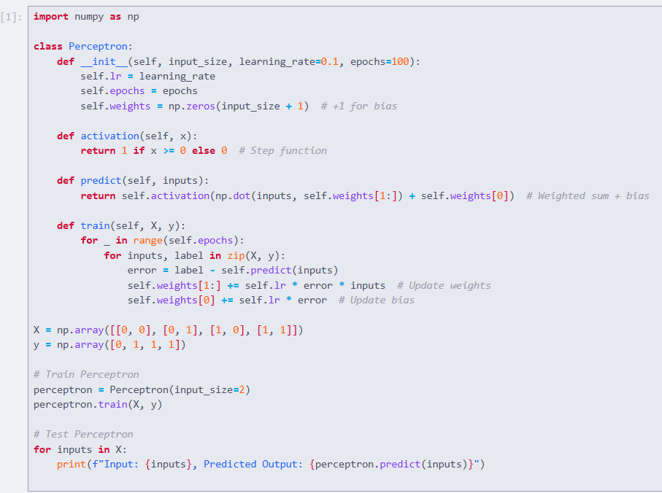

Practical 2: Implementation of multi-layer perceptron

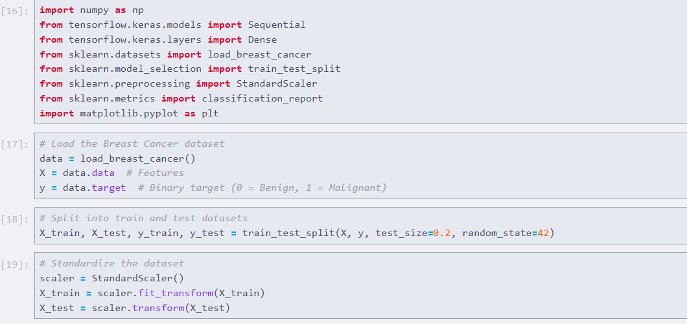
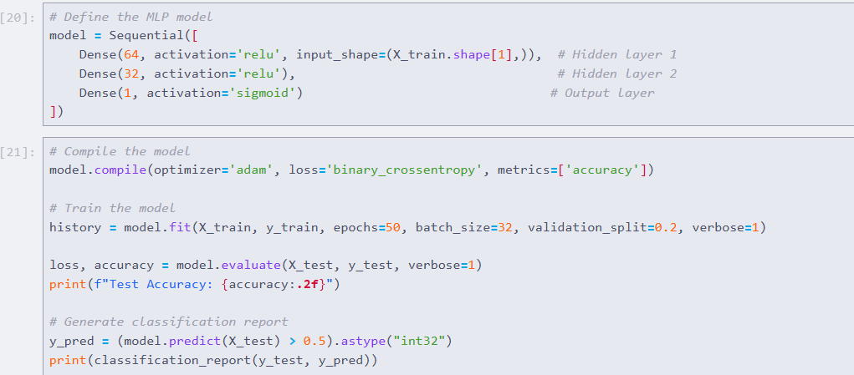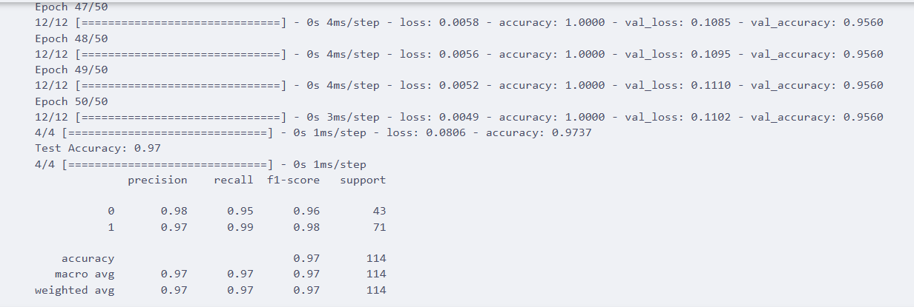

Practical 3: Perform backpropagation in neural network

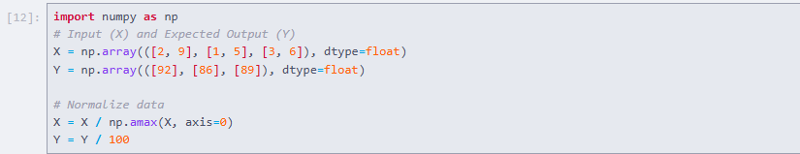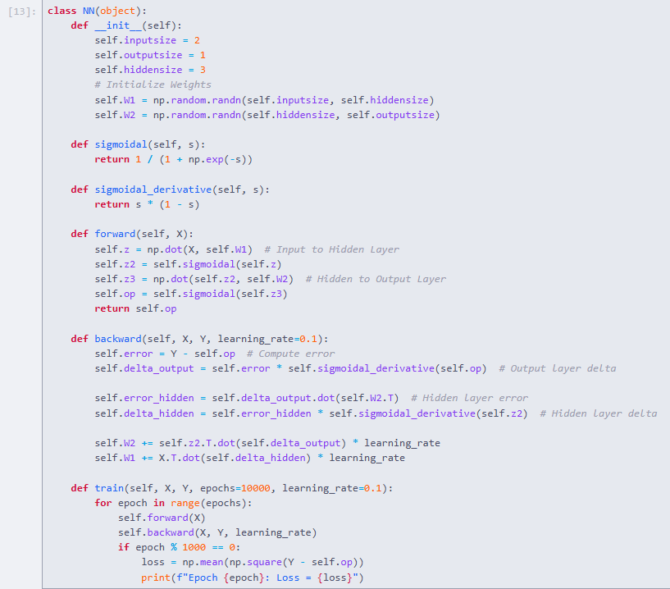
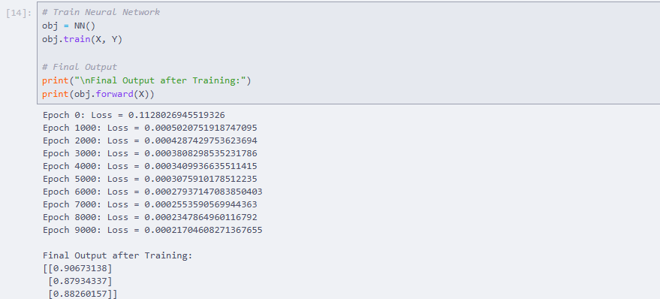

Practical 4: Implementation of fuzzy logic.

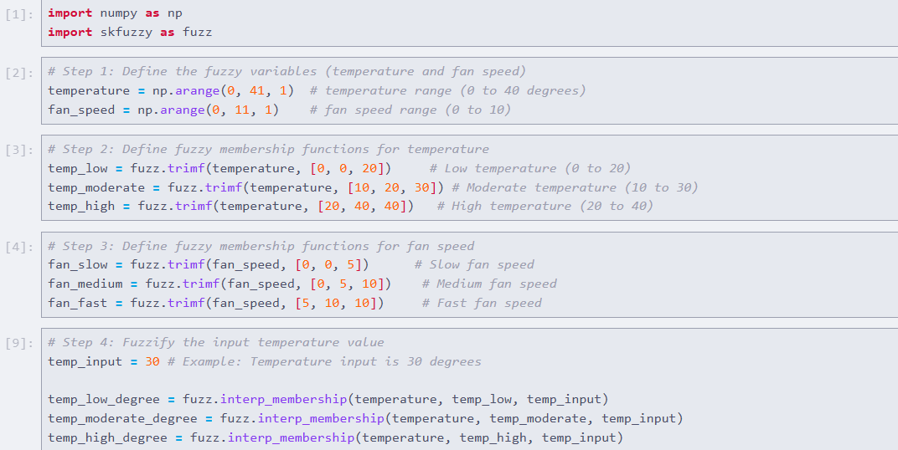
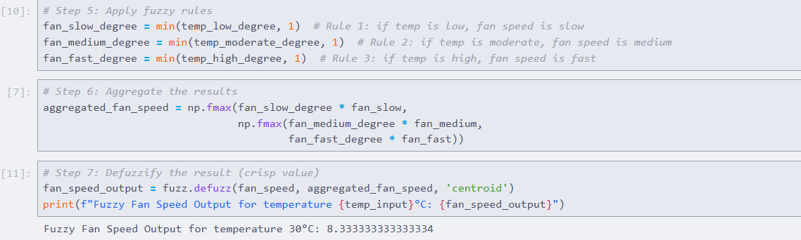

Practical 5: Implementation of heb rule learning

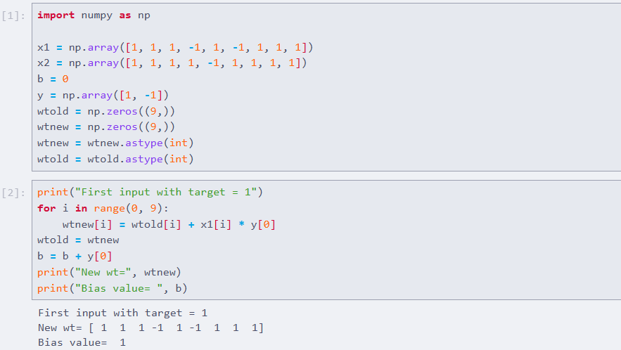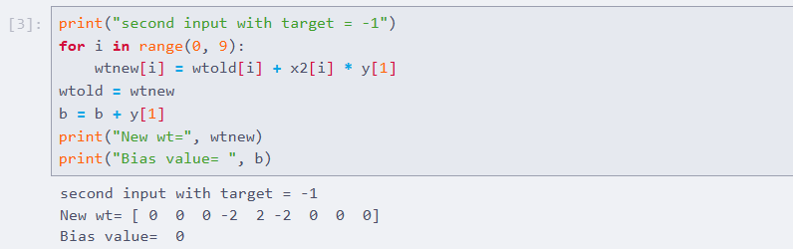

Practical 6: Implementation of self organizing map

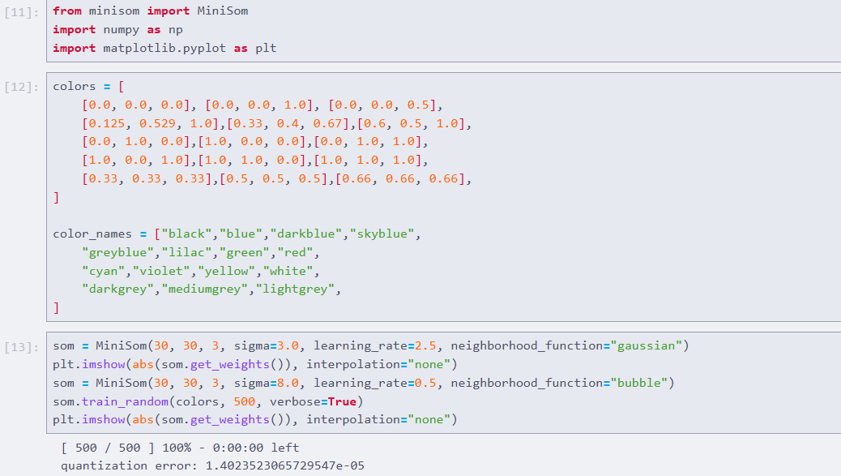
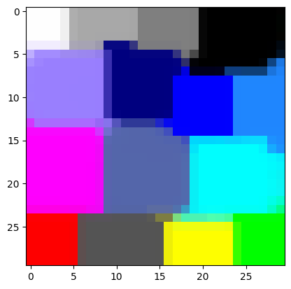

Practical 7: Implementation of delta rule learning

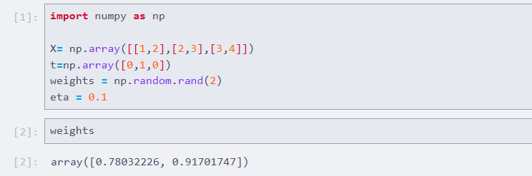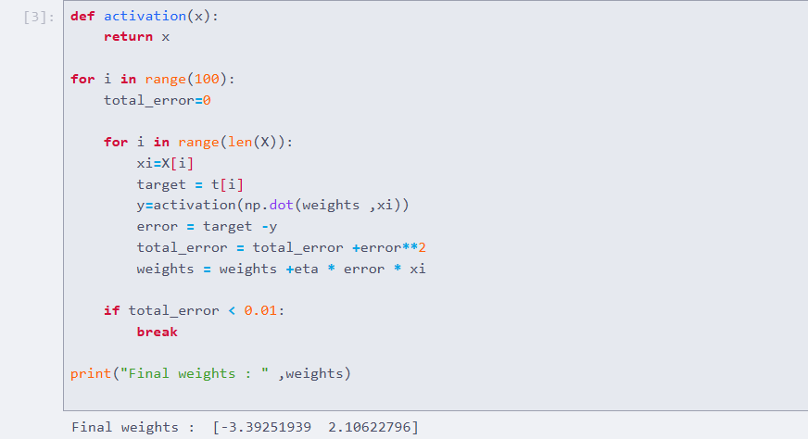

Practical 8: Implementation of genetic algorithm

